Shape Nets- Questions

Key Stage 2: 2003 Paper A
1.
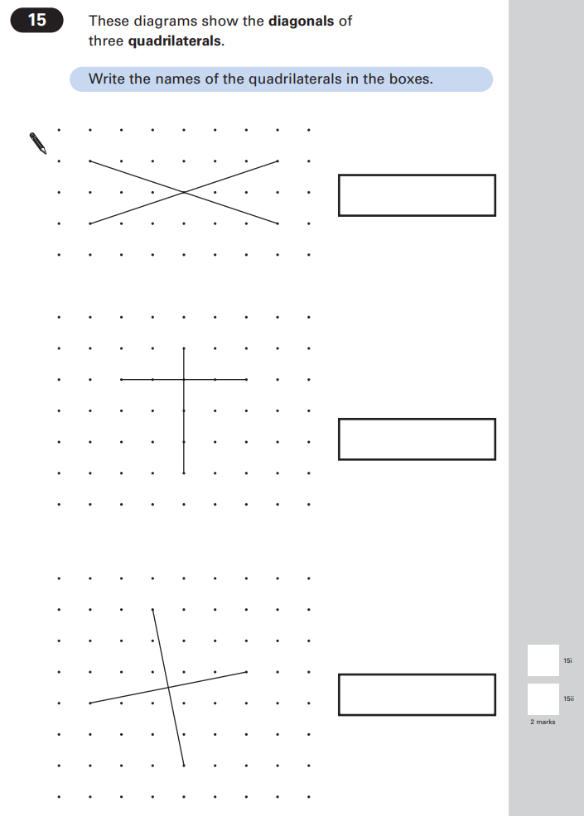

Key Stage 2: 2003 Paper B
1.
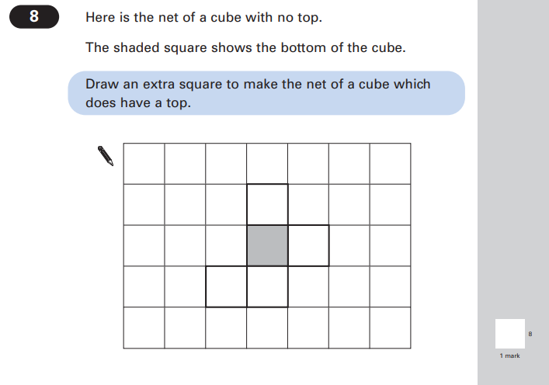

Key Stage 2: 2004 Paper A
1.
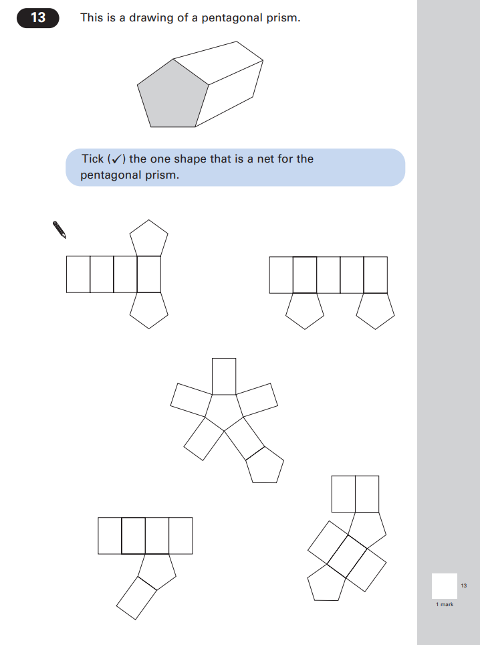

Key Stage 2: 2005 Paper A
1.
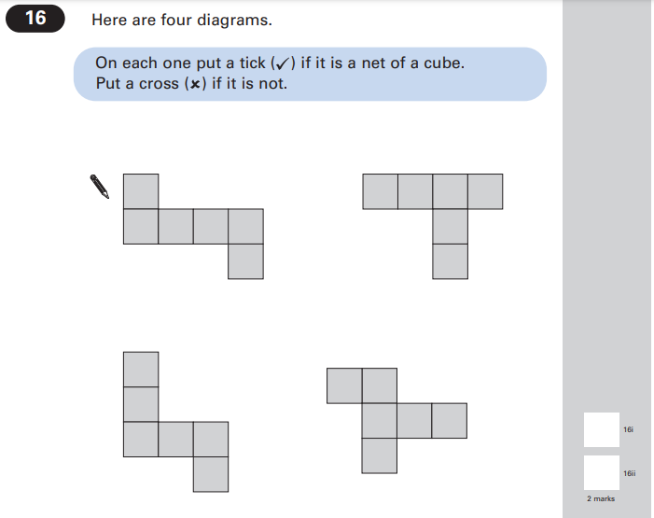

Key Stage 2: 2006 Paper B
1.
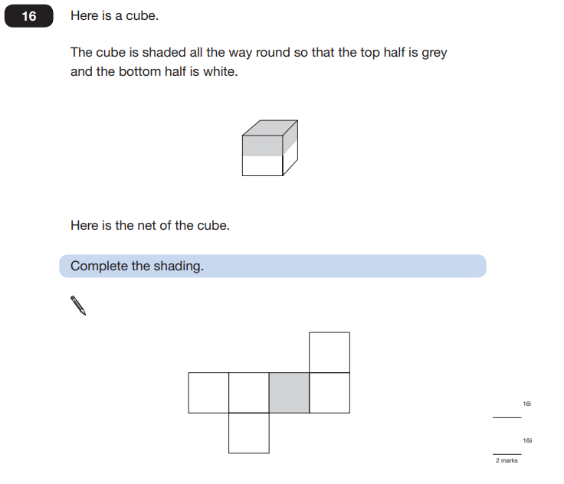

Key Stage 2: 2007 Paper A
1.
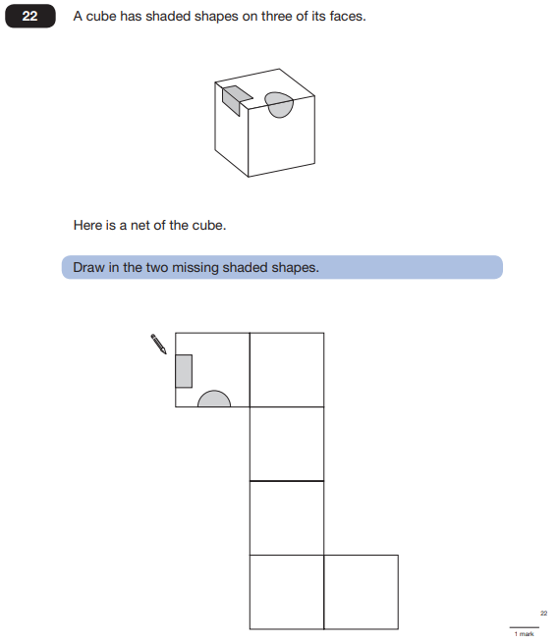

Key Stage 2: 2008 Paper A
1.
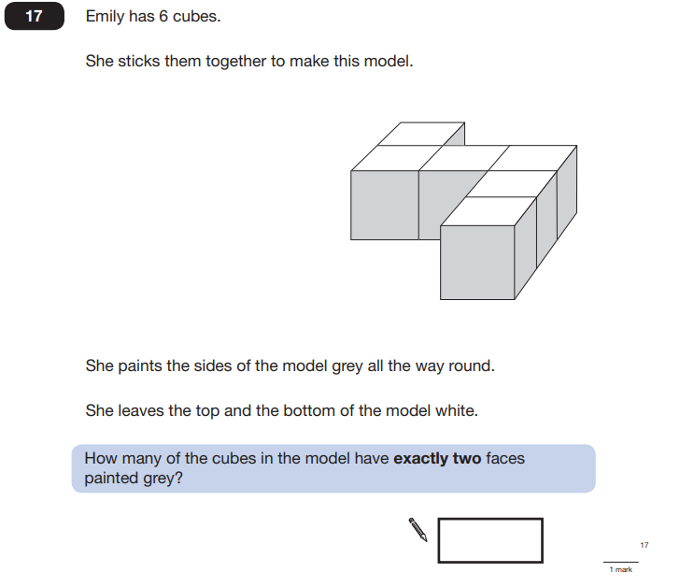

Key Stage 2: 2008 Paper B
1.
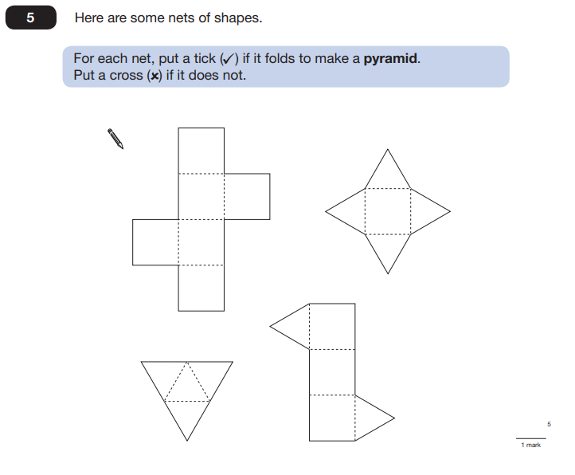

Key Stage 2: 2012 Paper B L6
1.
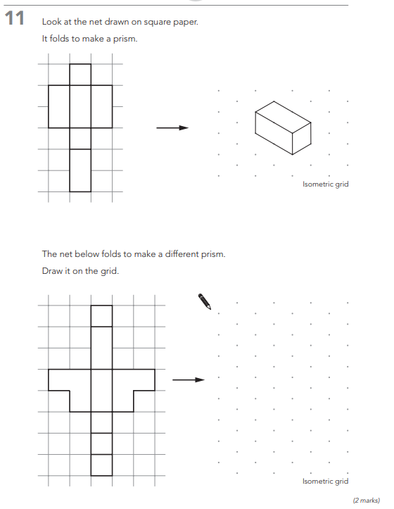

Key Stage 2: 2013 Paper A
1.
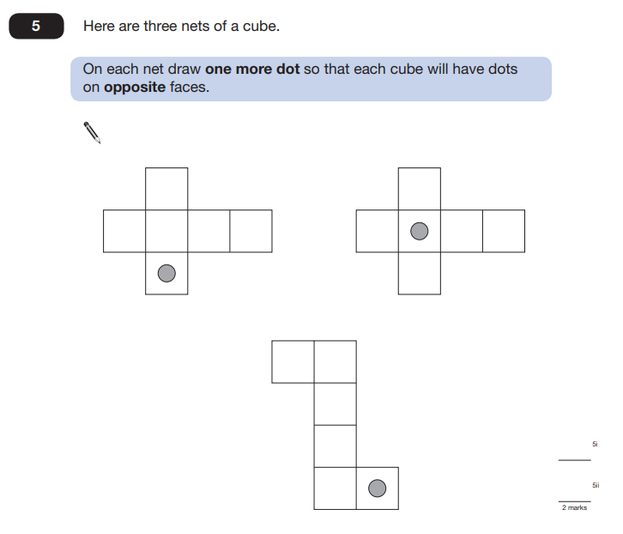

Key Stage 2: 2015 Paper B L6
1.
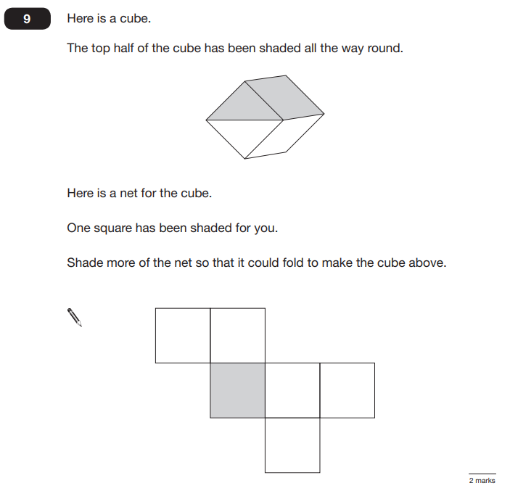

Key Stage 2: 2015 Paper B
1.
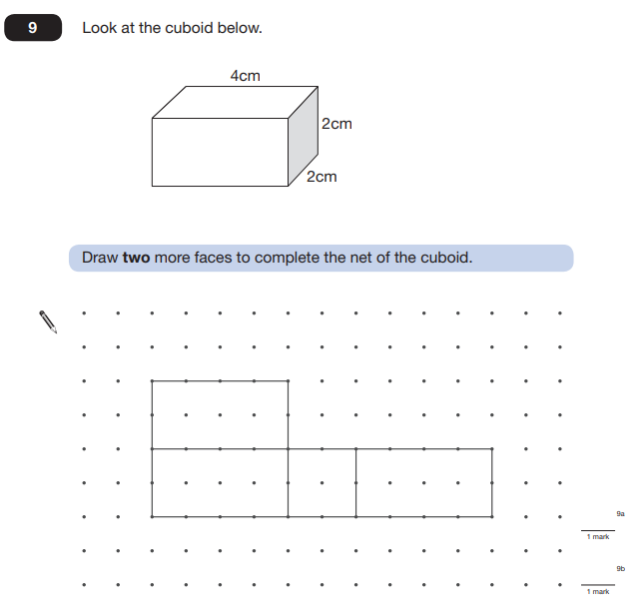

Key Stage 2: 2018 Paper 2 Reasoning
1.
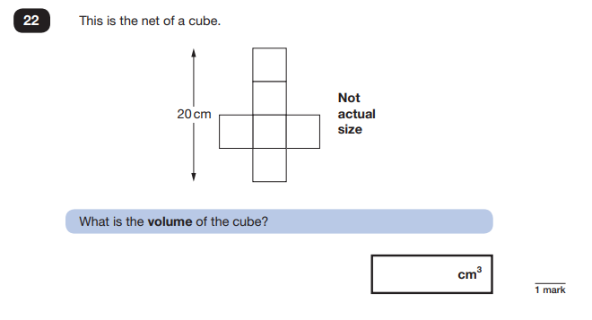
Key Stage 2: 2018 Paper 3 Reasoning
1.
